Q1:

1.This is my Jenkins file.. for over view I will give it in vscode and I will show

Running into ratelimit :

As dockerfile got build and the Kubernetes stage is stopped because of the pull rate limit:

See the Kubernetes stage which is correct which will definitely run kindly check..

So to show the ouput that the image is working I did it with docker container please check with that:

Pulling the image that I gave in the Jenkins file:

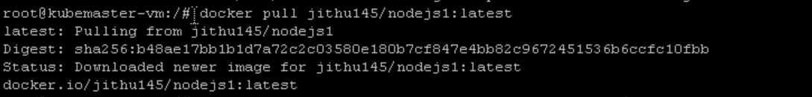

Running container with that image:

Went in to the docker checked with the localhost:3000 because it is node.js location its working

To show the files of kubernetes:

Deployment.yaml file:

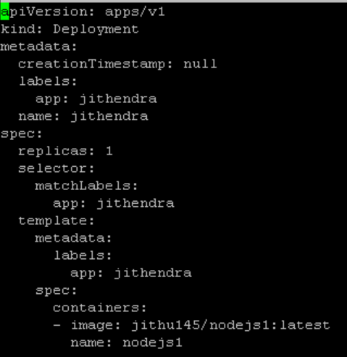

Service.yaml:

